**Patient Chart – Seizures**

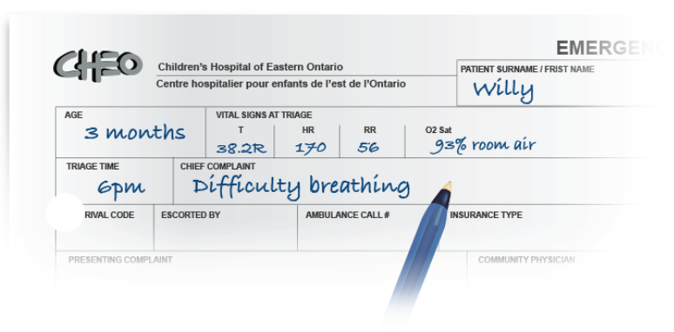

**Day 1, 22:25**

**MD note**

HPI: Prev.well. No reg meds. Well at bedtime 20:30.

~21:30 parents heard gurgling, found sitting in room. Awake but not verbally responsive. Drooling.

Rhythmic movt Rt side of mouth x 10 secs. Decreased use of RUL. Return to baseline at 2 min, no amnesia.

**Day 1, 23:47**

**RN note**

~2min seizure episode witnessed. Twitching L side of face, initial rhythmic jerking movt’s left arm, then jerking movements of entire body. MD paged stat.

**Day 1, 23:52**

**RN note**

MD arrived. Pt placed on monitor, Fi02 100% via face mask.

T: 36.5ax

HR: 115 BP: 120/75

RR: 15 irregular, airway patent

O2 sat: 100% room air (FiO2 100% NRB)

Bedside glucose: 5.5 mmol/L

**Day 1, 00:10**

**MD note**

2min Lt. sided focal seizure with secondary generalization witnessed by RN. (See RN note)

Now resolved. Normal bedside glucose.

O/E GCS 15, looks tired, pale. PERL, normal fundi, neck supple. CN II-XII normal. CN I not tested. Reflexes equal U/L bilat. Strength 4/5 LUL, all other equal 5/5. Normal tone. Plantars downgoing.

Chest clear. S1 & S2 no XS/mm. CR brisk. Addo soft, non-tender. No rashes.

**Day 2, 00:05**

**Investigations**

CBC & diff, lytes, serum glucose, VBG, Ca+2 normal

**Day 2, 06:00**

**MD note**

Reassessment: Lt arm weakness resolved. GCS 15, Remains afebrile, VSS.

Case discussed with neurology & EEG to be done this am.

**Day 2, 11:30**

**MD note**

Clinically stable. EEG shows no epileptiform activity. Labs normal.

Requisition sent for outpatient MRI, repeat EEG (sleep deprived).

D/C and follow-up neurology as outpatient later this week. Sz teaching completed with parents.

**Day 5, 14:00**

**Neurology outpatient clinic**

EEG consistent with BECTS. See EEG report. MRI booked.

F/U neurology clinic 3/12.